Supplementary Figures

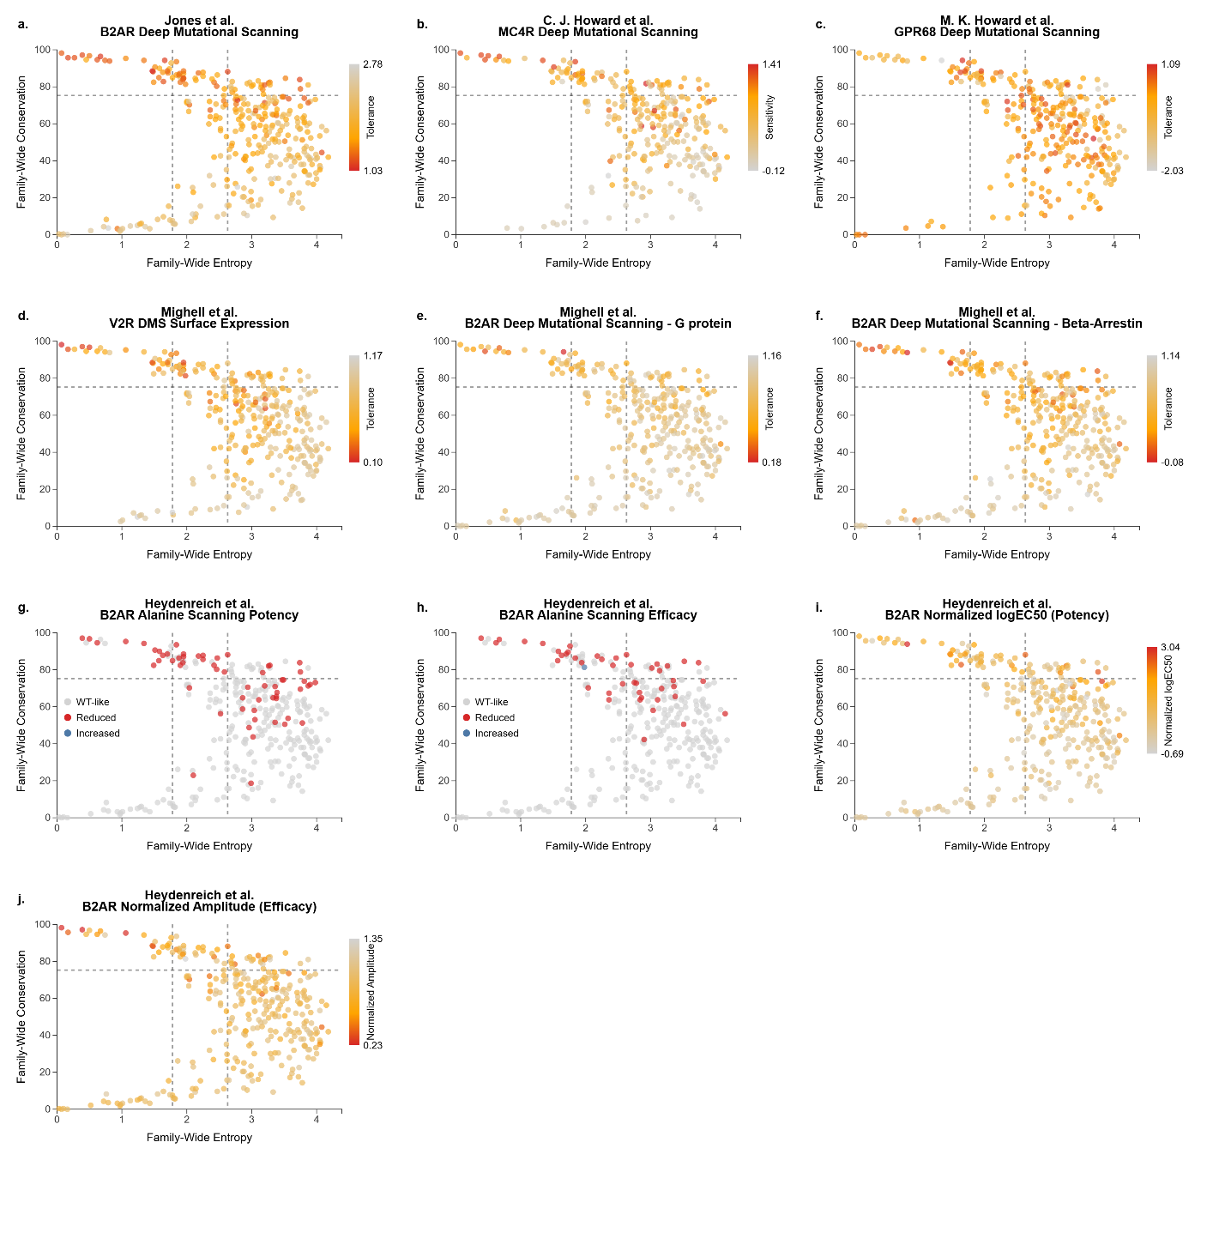
Figure S1: Individual benchmarking of class A-wide evolutionary patterns against deep mutational and alanine scanning experiments. a. For each residue, its mutational intolerance score for B2AR (Beta-2 Adrenergic Receptor) ¹ is mapped onto the class A scatter plot (Figure 2a). Colors represent decreasing mutational tolerance, ranging from grey (tolerant) through orange to red (highly intolerant). b. Similar representation for mutational sensitivity (inverse of tolerance) for MC4R (Melanocortin 4 Receptor)² with similar coloring. c. Mutational tolerance of GPR68 (Proton-sensing G-protein Coupled Receptor)³ was illustrated with similar coloring. d. Mutational tolerance calculated based on surface expression of V2R (Vasopressin 2 Receptor)⁴. e-d. Mutational tolerance calculated based on B2AR activa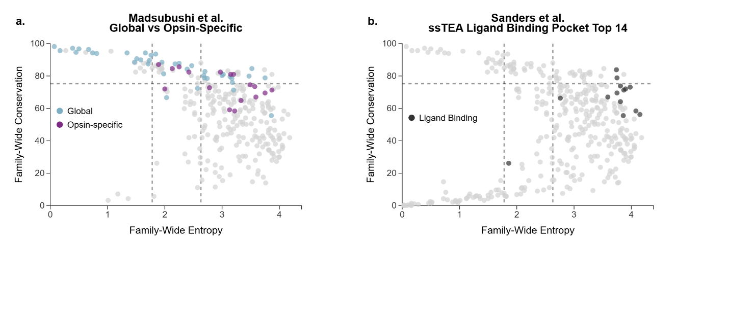tion against G protein and Beta-arrestin activity.⁵ g-h. Increases or decreases in potency and efficacy are labeled for B2AR in response to alanine scanning⁶. Alanine scanning data is not used for the main text, but added as an additional benchmarking. i-j Actual measurements for efficacy and potency are mapped on to class A scatter plot.
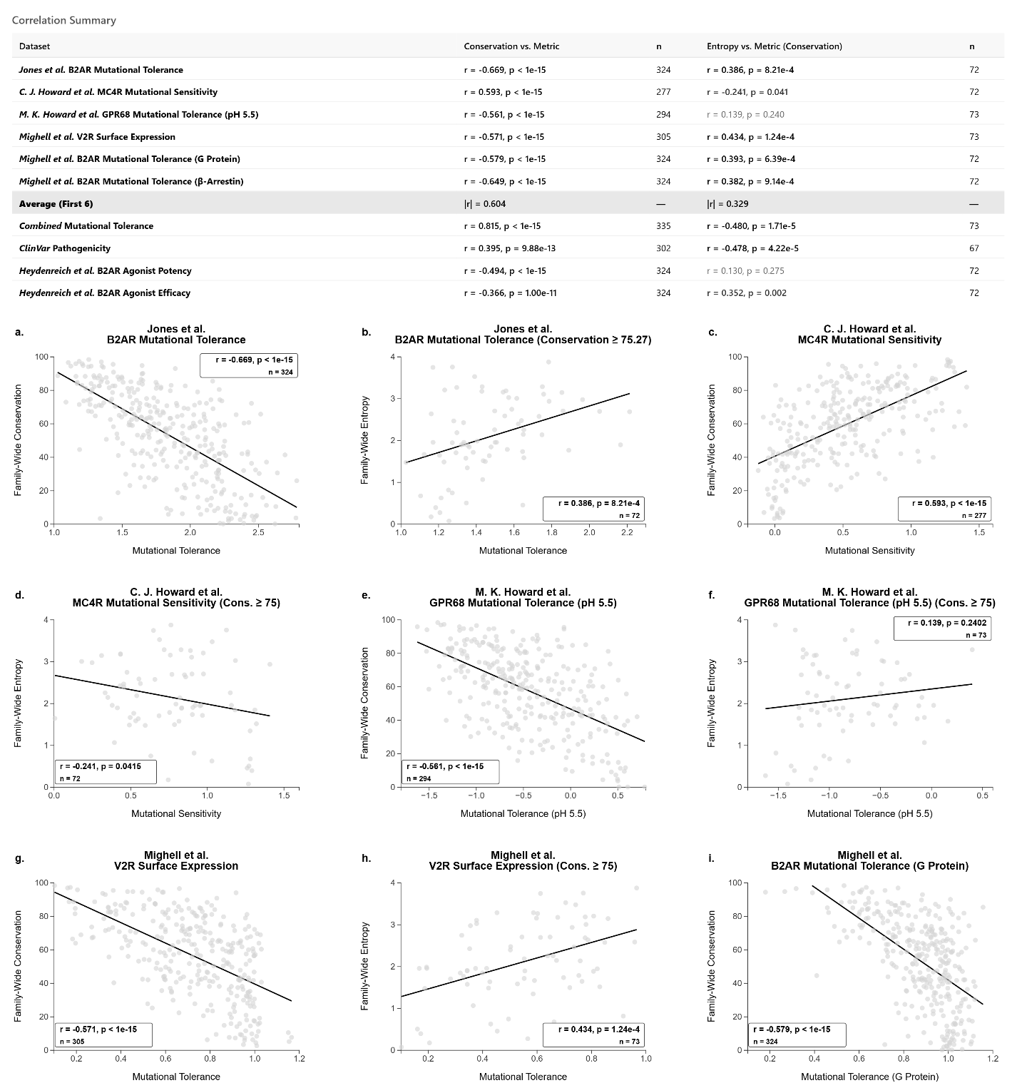

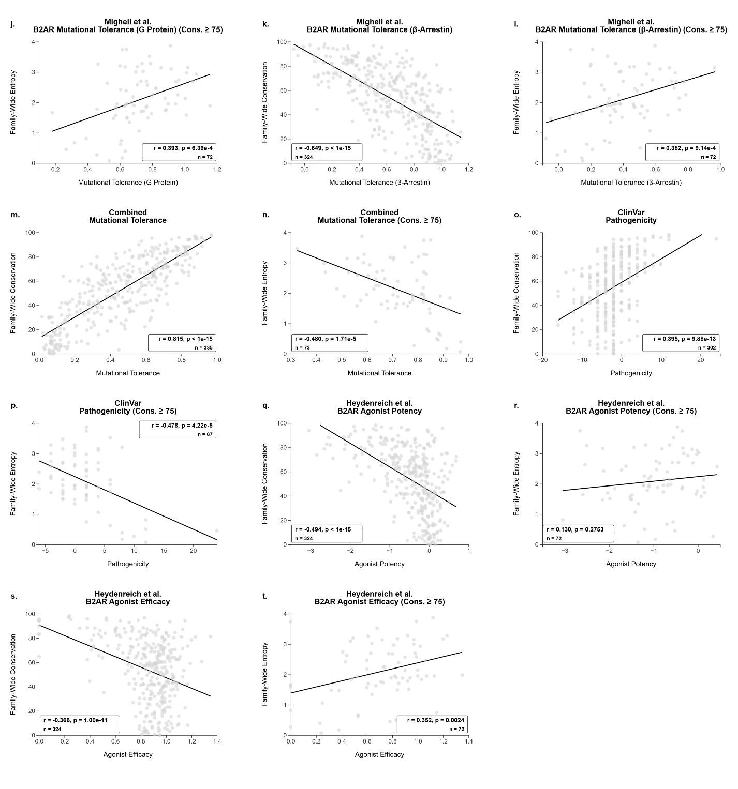
Figure S2: Correlation of class A-wide evolutionary metrics with mutational tolerance and pathogenicity. a. Correlation summary table reporting Pearson r, p‑values and sample sizes for relationships between class A conservation or entropy at highly conserved sites and the indicated quantitative metrics. Correlation summary table reporting Pearson r, p‑values and sample sizes for relationships between class A conservation or entropy at highly conserved sites and the indicated quantitative metrics. b-c. Correlation of B2AR mutational tolerance with conservation and entropy. d-e. Correlation of MC4R mutational sensitivity with conservation and entropy. f-g. Correlation of GPR68 mutational tolerance at pH 5.5 with conservation and entropy. h-i. Correlation of V2R surface‑expression-derived mutational tolerance with conservation and entropy. j-k. Correlation of B2AR G‑protein-based mutational tolerance with conservation and entropy. l-m. Correlation of B2AR β‑arrestin-based mutational tolerance with conservation and entropy. n-o. Correlation of a combined class A mutational tolerance score with conservation and entropy. p-q. Correlation of ClinVar pathogenicity scores with conservation and entropy. r-s. Correlation of B2AR agonist potency (normalized logEC50) with conservation and entropy. t-u. Correlation of B2AR agonist efficacy (normalized amplitude) with conservation and entropy.

Figure S3: Comparison of class A-wide conservation patterns against previous evolutionary studies. a. Comparison with global (analogous to CRs) and opsin-specific (analogous to SRs) residues identified by Madsubshi et al. Global positions are colored as light blue, opsion-specific ones are colored as purple. b. Comparison of most significant 14 residues identified as candidate ligand binding positions by using ssTEA approach. Residues are shown in black color.

1 Jones, E. M. et al. Structural and functional characterization of G protein-coupled receptors with deep mutational scanning. eLife 9 (2020). https://doi.org:10.7554/elife.54895
2 Howard, C. J. et al. High resolution deep mutational scanning of the melanocortin-4 receptor enables target characterization for drug discovery (eLife Sciences Publications, Ltd, 2025).
3 Howard, M. K. et al. Molecular basis of proton sensing by G protein-coupled receptors. Cell 188, 671-687.e620 (2025). https://doi.org:https://doi.org/10.1016/j.cell.2024.11.036
4 Mighell, T. L. & Lehner, B. A small molecule stabilizer rescues the surface expression of nearly all missense variants in a GPCR. Nature Structural & Molecular Biology (2025). https://doi.org:10.1038/s41594-025-01659-6
5 Mighell, T. L. & Lehner, B. The genetic architecture of G-protein coupled receptor signaling (Cold Spring Harbor Laboratory, 2025).
6 Heydenreich, F. M. et al. Molecular determinants of ligand efficacy and potency in GPCR signaling. Science 382, eadh1859 (2023). https://doi.org:doi:10.1126/science.adh1859

